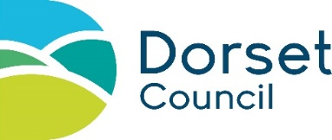
Special events and street parties – engagement exercise
Your traffic management proposals might affect access to buildings, local businesses, local bus services or any number of other interests, so it is important that you engage with stakeholders who could be affected by the traffic restrictions in place for your event, mitigate any issues and meet any reasonable requests.
The amount of engagement you need to undertake should be determined by the scale and potential impact of your event. If you want to discuss engagement for your event, please contact the Traffic Team: trafficteam@dorsetcouncil.gov.uk.
Type of stakeholder |  | Have stakeholders been notified?  (Delete as appropriate) |  |  | How have the stakeholders been contacted? |  | Any comments from stakeholders, responses and any mitigating measures that will be taken
Locally affected residents and businesses |  | Yes / No / n/a
Town and/or parish councils  https://www.dorsetcouncil.gov.uk/your-council/parish-and-town-councils/parishatoz |  | Yes / No / n/a
All emergency services  Dorset Police; Dorset and Wiltshire Fire and Rescue; SW Ambulance |  | Yes / No / n/a
Local Authority services, including: |  | Yes / No / n/a
Recycling and waste collections  Contact waste services |  | Yes / No / n/a
School and community transport  Contact Dorset Travel |  | Yes / No / n/a
Parking services  (on-street/off-street parking) Contact parking services |  | Yes / No / n/a
Bus operators  Contact Dorset bus operators |  | Yes / No / n/a
Taxi operators  Check local listings |  | Yes / No / n/a
Affected landowners, farmers |  | Yes / No / n/a
Any other relevant stakeholders (please specify) |  | Yes / No / n/a
I declare that this is a genuine reflection of the engagement carried out for this event.
Event organiser name: |  |  | Dated: |  |  | Event name:
When complete, please save this document and upload it to your application.

